

**Software Design Description**

**Hanoi, April 12th, 20201**

**Table of Contents**

**Chapter 4: Software Design Description** 2

**4****.1. System Architecture Design**

***4.2******.1. Choice of System Architecture***

***4.2******.2. Discussion of Alternative Designs***

***4.2******.3. Description of System Interface***

**4****.3. Component Diagram** 2

**4****.4. Detailed Description of Components** 3

***4***[***.4.1. CRC Cards (Class-Responsibility-Collaborators)*** *3*](https://docs.google.com/document/d/1gRhesEx9OtIXu6NM8EbwjelwWmyH6FQW/edit#heading=h.17dp8vu)

***4.4.1.n. Component-n***

***4.4.1.n.1. Class Diagram***

***4.4.2.n.2. Class Diagram Explanation***

***4.4.3.n.3. Algorithms of important methods in each class, specified in pseudo code or by Flow-Chart***

**4****.5. Sequence Diagram** 3

**4****.6. User Interface Design** 5

***4******.6.1. Description of the User Interface*** 5

***4******.6.12.1 Screen Images*** 6

***1.6.12.2*** ***Objects and Actions*** *7*

**4.7. Database Design or Data Structures 5**

**4****.8. Other material (if any)**

# **Detailed Description of Components**

## **4.1. System Architecture Design**

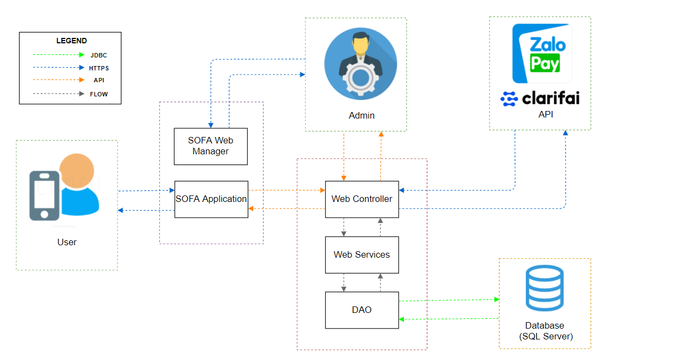

*Figure 4.1 – System Architecture Design*

## 

## **4.1.0 Software Architecture Design**

## 

*Figure 4.2 – Software Architecture Design*

## ***4.1.1. Choice of System Architecture***

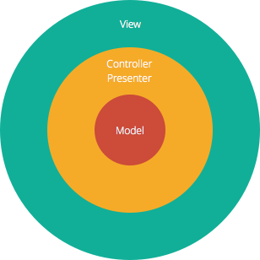

*Figure 4.2 – Model-View-Controller pattern*

The Model-View-Controller (MVC) structure, which is the standard software development approach offered by most of the popular web frameworks, is clearly a layered architecture. Just above the database is the model layer, which often contains business logic and information about the types of data in the database. At the top is the view layer, which is often CSS, JavaScript, and HTML with dynamic embedded code. In the middle, you have the controller, which has various rules and methods for transforming the data moving between the view and the model.

## ***4.1.2. Description of System Interface***

***4.1.2.1. Database management system***

## 

*Database management system*

Database management system is a software which is used to manage the database. For example: SQL Server, MySQL, Oracle, etc are a very popular commercial database which is used in different applications. DBMS provides an interface to perform various operations like database creation, storing data in it, updating data, creating a table in the database and a lot more. It provides protection and security to the database. In the case of multiple users, it also maintains data consistency.

***4.1.2.2. Web browser***

## 

*Browsers*

A web browser (commonly referred to as a browser) is a software application for accessing information on the World Wide Web. When a user requests a web page from a particular website, the web browser retrieves the necessary content from a web server and then displays the page on the user's device. A web browser is not the same thing as a search engine, though the two are often confused. For a user, a search engine is just a website that provides links to other websites. However, to connect to a website's server and display its web pages, a user must have a web browser installed. Web browsers are used on a range of devices, including desktops, laptops, tablets, and smartphones. . In 2019, an estimated 4.3 billion people used a browser.

***4.1.2.3. Google Authenticator***

**

*Google Authenticator*

Google Authenticator is a software-based authenticator by Google that implements two-step verification services using the Time-based One-time Password Algorithm and HMAC-based One-time Password[1] algorithm , for authenticating users of software applications.

When logging into a site supporting Authenticator (including Google services) or using Authenticator-supporting third-party applications such as password managers or file hosting services, Authenticator generates a six- to eight-digit one-time password which users must enter in addition to their usual login details.

***4.1.2.3. Simple Mail Transfer Protocol (SMTP)***



*Simple Mail Transfer Protocol*

The Simple Mail Transfer Protocol (SMTP) is a communication protocol for electronic mail transmission. As an Internet standard, SMTP was first defined in 1982 by RFC[2] 821, and updated in 2008 by RFC 5321 to Extended SMTP additions, which is the protocol variety in widespread use today. Mail servers and other message transfer agents use SMTP to send and receive mail messages. SMTP servers commonly use the Transmission Control Protocol on port number 25.

User-level email clients typically use SMTP only for sending messages to a mail server for relaying, and typically submit outgoing email to the mail server on port 587 or 465 as per RFC 8314. For retrieving messages, IMAP[3] and POP3[4] are standard, but proprietary servers also often implement proprietary protocols, e.g.

**4.2.**  **Component Diagram**

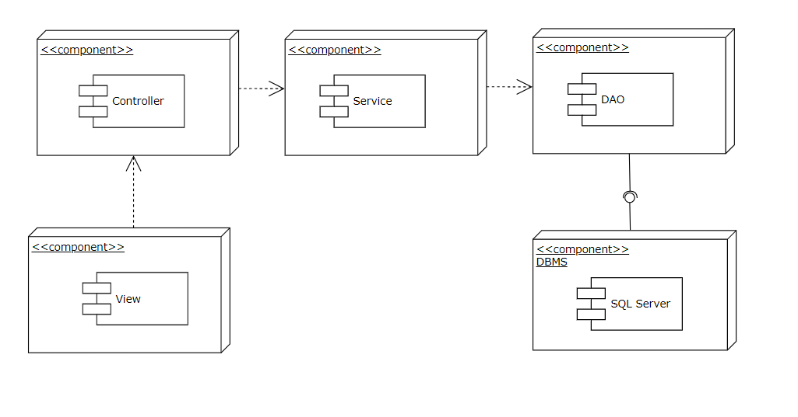

## **4.3. Detailed Description of Component**

***4.3.1. View***

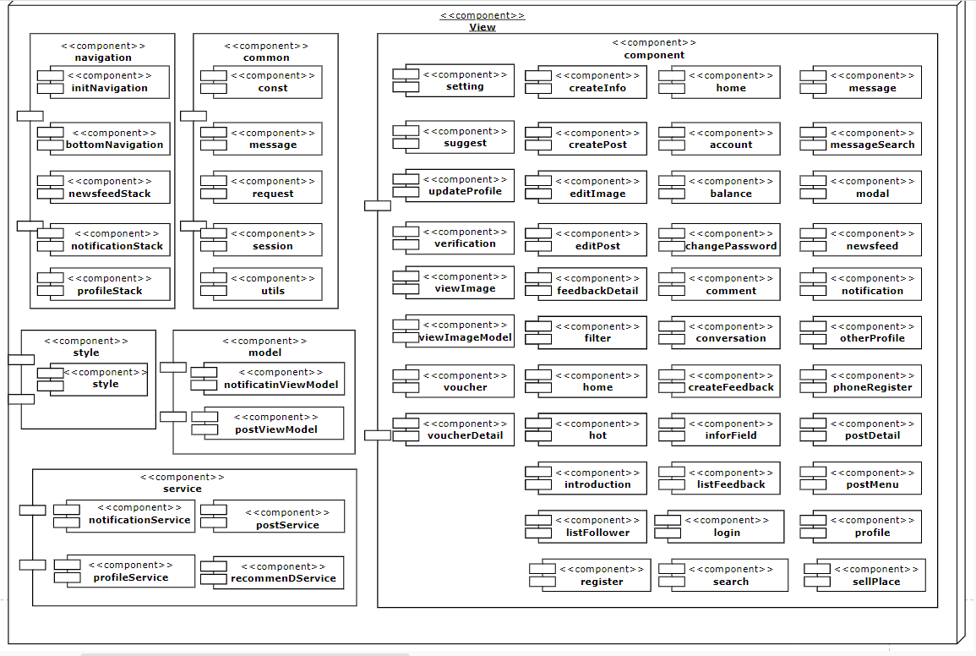

## **4.4. Class Diagram**

***4.4.1. Class diagram***

***4.4.1.1. Post Class Diagram***

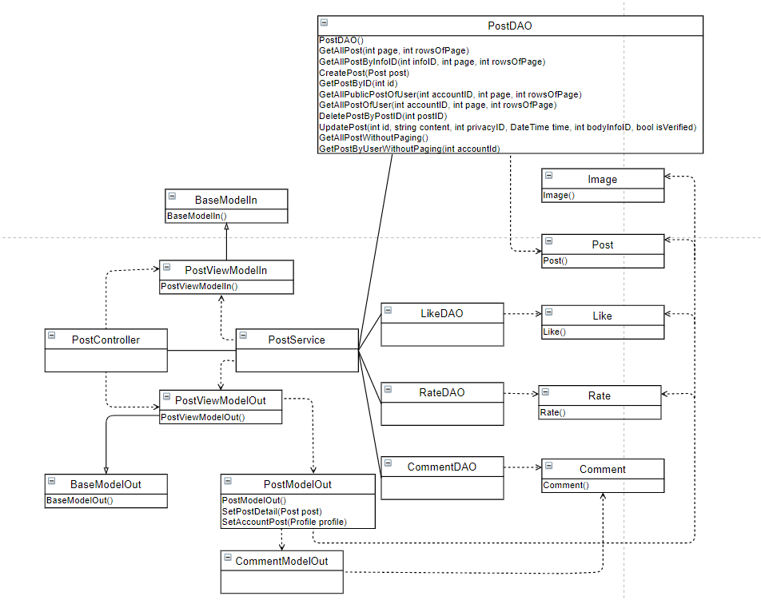

***4.4.1.2. Account Class Diagram***

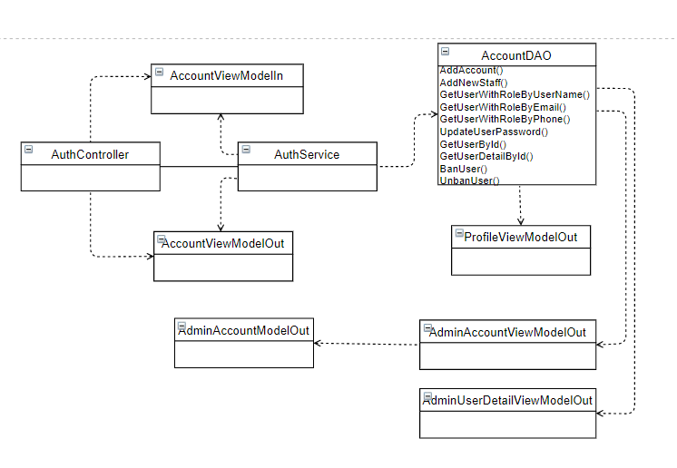

***4.4.1.3. Profile Class Diagram***

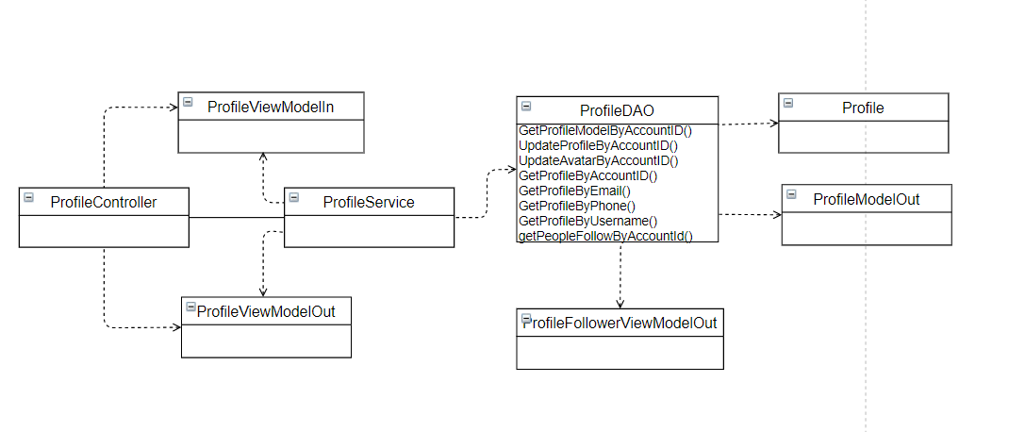

***4.4.1.4. Notification Class Diagram***

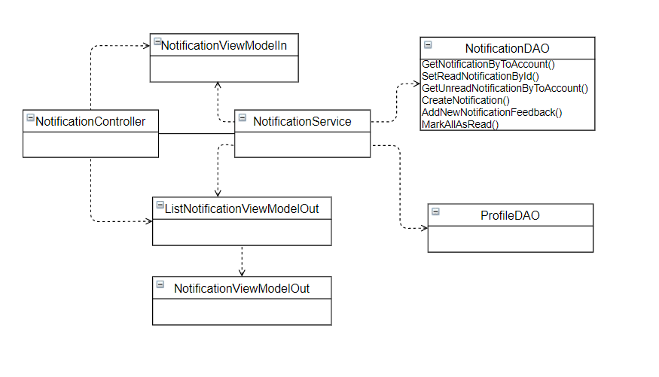

***4.4.1.5. Message Class Diagram***

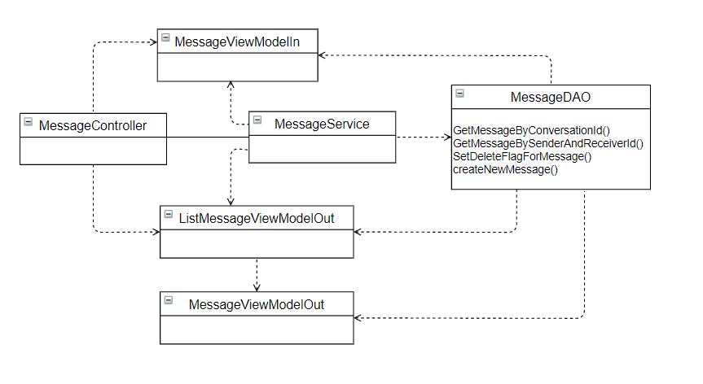

***4.4.2. Models***

***4.4.2.1 Account***

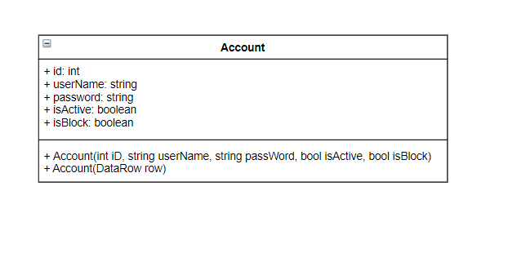

**Class specification**

|  |  |  |  |
| --- | --- | --- | --- |
| **NO** | **Attribute** | **Type** | **Description** |
| 01 | id | int | ID of account |
| 02 | username | string | User Name of account |
| 03 | password | string | Password of account |
| 04 | isActive | boolean | Status active of account |
| 05 | isBlock | boolean | Status block of account |

|  |  |  |
| --- | --- | --- |
| **NO** | **Method** | **Description** |
| 01 | Account(int iD, string userName, string password, bool isActive, bool isBlock) | Default constructor |
| 02 | Account(DataRow row) | Another constructor |

***4.4.2.2 AccountLog***

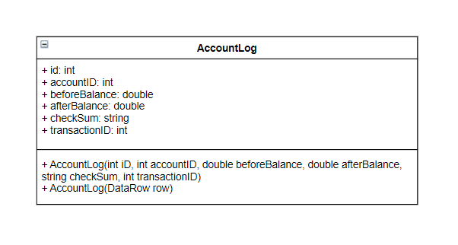

**Class specification**

|  |  |  |  |
| --- | --- | --- | --- |
| **NO** | **Attribute** | **Type** | **Description** |
| 01 | id | int | ID of log |
| 02 | accountID | int | ID of account log |
| 03 | beforeBalance | double | Balance of account before transaction |
| 04 | afterBalance | double | Balance of account after transaction |
| 05 | transactionID | int | ID of transacation |

|  |  |  |
| --- | --- | --- |
| **NO** | **Method** | **Description** |
| 01 | AccountLog(int iD, int accountID, double beforeBalance, double afterBalance, int transactionID) | Default constructor |
| 02 | AccountLog(DataRow row) | Another constructor |

***4.4.2.3 Comment***

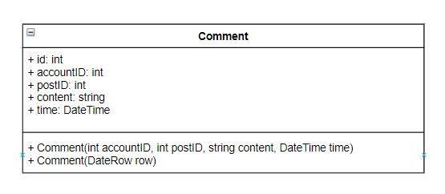

**Class specification**

|  |  |  |  |
| --- | --- | --- | --- |
| **NO** | **Attribute** | **Type** | **Description** |
| 01 | id | int | Id of comment |
| 02 | accountID | int | Id of account comment |
| 03 | postID | int | Id of the post |
| 04 | content | string | Content of the comment |
| 05 | time | DateTime | Time comment is created |

|  |  |  |
| --- | --- | --- |
| **NO** | **Method** | **Description** |
| 01 | Comment(int id, int accountID, int postID, string content, Datetime time) | Default constructor |
| 02 | Comment(DataRow row) | Another constructor |

***4.5.2.4 Feedback***

**Class specification*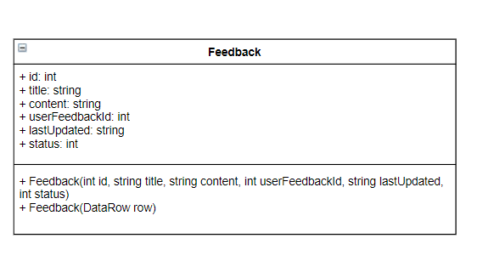***

|  |  |  |  |
| --- | --- | --- | --- |
| **NO** | **Attribute** | **Type** | **Description** |
| 01 | id | int | Id of the feedback |
| 02 | title | string | Title of the feedback |
| 03 | content | string | Content of the feedback |
| 04 | userFeedbackId | id | Id of the user have send feedback |
| 05 | lastUpdated | string | The final date update the feedback |
| 06 | status | int | Status of Feedback :   * Status = 1 : Resolved * Status = 2 : Unresolved * Status = 3 : Rejected |

|  |  |  |
| --- | --- | --- |
| **NO** | **Method** | **Description** |
| 01 | Feedback(int id,string title, string content, int userFeedbackId, string lastUpdated, int status) | Default constructor |
| 02 | Feedback(DataRow row) | Another constructor |

***4.4.2.5 Follow***

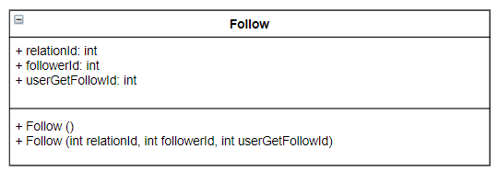

**Class specification**

|  |  |  |  |
| --- | --- | --- | --- |
| **NO** | **Attribute** | **Type** | **Description** |
| 01 | relationId | int | Relation of the Following :   * Relation = 1 : Follow * Relation = 2 : Block |
| 02 | followerId | int | Id of the user follow |
| 03 | userGetFollowId | int | Id of the user is followed |

|  |  |  |
| --- | --- | --- |
| **NO** | **Method** | **Description** |
| 01 | Follow() | Default constructor |
| 02 | Follow(int relationId, int followerId, int userGetFollowId) | Another constructor |

***4.4.2.6 Image***

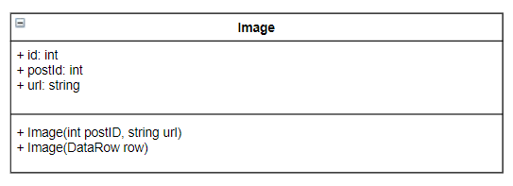

**Class specification**

|  |  |  |  |
| --- | --- | --- | --- |
| **NO** | **Attribute** | **Type** | **Description** |
| 01 | id | int | Id of the image |
| 02 | postId | int | Id of the post contain the image |
| 03 | url | string | The path to the image file |

|  |  |  |
| --- | --- | --- |
| **NO** | **Method** | **Description** |
| 01 | Image(int postID, string url) | Default constructor |
| 02 | Image(DataRow row) | Another constructor |

***4.4.2.7 Infor***

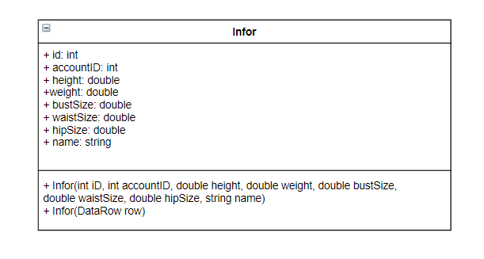

**Class specification**

|  |  |  |  |
| --- | --- | --- | --- |
| **NO** | **Attribute** | **Type** | **Description** |
| 01 | id | int | Id of the Infor |
| 02 | accountID | int | Id of the account have the infor |
| 03 | height | double | Height of the person |
| 04 | weight | double | Weight of the person |
| 05 | bustSize | double | The size of the butt |
| 06 | waistSize | double | The size of the waist |
| 07 | hipSize | double | Size of the hip |
| 08 | name | string | Name of the Infor |

***4.4.2.8 Message***

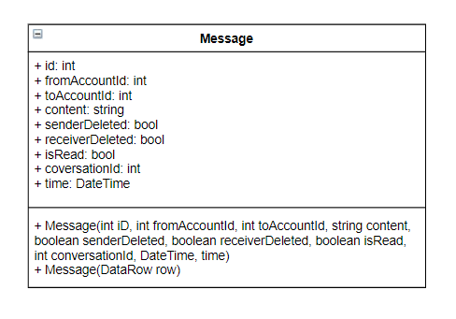

**Class specification**

|  |  |  |  |
| --- | --- | --- | --- |
| **NO** | **Attribute** | **Type** | **Description** |
| 01 | id | int | Id of the message |
| 02 | fromAccountId | int | Id of sender |
| 03 | toAccountId | int | Id of the receiver |
| 04 | content | string | Content of the message |
| 05 | senderDeleted | boolean | Status of the message on sender :   * Status = 0 : UnDeleted * Status = 1 : Deleted |
| 06 | receiverDeleted | boolean | Status of the message on receiver:   * Status = 0 : Undeleted * Status = 1 : Deleted |
| 07 | isRead | boolean | Status of the message on receiver is read:   * Relation = 0 : Unread * Relation = 1 : Read |
| 08 | conversationId | int | Id of the conversation |
| 09 | time | DateTime | Time of the message |

|  |  |  |
| --- | --- | --- |
| **NO** | **Method** | **Description** |
| 01 | Message(int iD, int fromAccountId, int toAccountId, string content,boolean senderDeleted, boolean receiverDeleted, boolean isRead,int conversationId, DateTime, time) | Default constructor |
| 02 | Message(DataRow row) | Another constructor |

**4.5.3. DAO**

***4.5.3.1 AccountDAO***

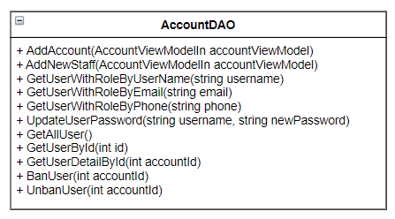

**Class specification**

|  |  |  |
| --- | --- | --- |
| **NO** | **Method** | **Description** |
| 01 | AddAccount(AccountViewModelIn accountViewModel) | Create an account for users |
| 02 | AddNewStaff(AccountViewModelIn) | Create a new account for staff manager |
| 03 | GetUserWithRoleByUserName(string username) | Get information of users with their username |
| 04 | GetUserWithRoleByEmail(string username) | Get information of users with their Email |
| 05 | GetUserWithRoleByPhone(string username) | Get information of users with their Phone |
| 06 | UpdateUserPassword(string username, string newPassword) | Change user password |
| 07 | GetAllUser() | Get all user in system |
| 08 | GetUserById(int id) | Get an user’s account and profile by his/her ID |
| 09 | GetUserDetailById(int id) | Get an user’s profile and statistics |
| 10 | BanUser(int accountId) | Ban an user |
| 11 | UnbanUser(int accountId) | Unban an user |

***4.5.3.2. ProfileDAO***

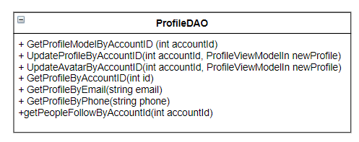

**Class specification**

|  |  |  |
| --- | --- | --- |
| **NO** | **Method** | **Description** |
| 01 | GetProfileModelByAccountID (int accountId) | Get an custom profile by account id |
| 02 | UpdateProfileByAccountID(int accountId, ProfileViewModelIn newProfile) | Update an profile by account id |
| 03 | UpdateAvatarByAccountID(int accountId, ProfileViewModelIn newProfile) | Update an user’s profile avatar by account id |
| 04 | GetProfileByAccountID(int id) | Get user’s profile by account id |
| 05 | GetProfileByEmail(string email) | Get user’s profile by user’s email |
| 06 | GetProfileByPhone(string phone) | Get user’s profile by user’s phone |
| 07 | getPeopleFollowByAccountId(int accountId) | Get people follow an account by account id |

***4.5.3.3 PostDAO***

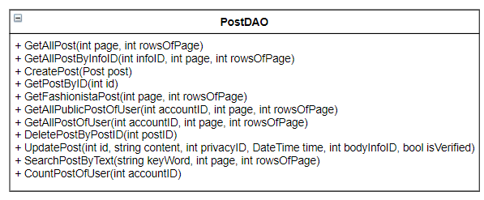

**Class specification**

|  |  |  |
| --- | --- | --- |
| **NO** | **Method** | **Description** |
| 01 | GetAllPost(int page, int rowsOfPage) | Get all public post in the system |
| 02 | GetAllPostByInfoID(int infoID, int page, int rowsOfPage) | Get all public post have body measurement equal infor id |
| 03 | CreatePost(Post post) | Create an post |
| 04 | GetPostByID(int id) | Get an post by its id |
| 05 | GetFashionistaPost(int page, int rowsOfPage) | Get fashionista’s post |
| 06 | GetAllPublicPostOfUser(int accountID, int page, int rowsOfPage) | Get all public post of user in the system |
| 07 | DeletePostByPostID(int postID) | Delete a post by its id |
| 08 | UpdatePost(int id, string content, int privacyID, DateTime time, int bodyInfoID, bool isVerified) | Update a post |
| 09 | SearchPostByText(string keyWord, int page, int rowsOfPage) | Search a post by keyword |
| 10 | CountPostOfUser(int accountID) | Get number of an user’s post |

***4.5.3.4 MessageDAO***

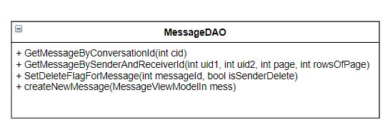

**Class specification**

|  |  |  |
| --- | --- | --- |
| **NO** | **Method** | **Description** |
| 01 | GetMessageByConversationId(int cid) | Get messages by conversation id |
| 02 | GetMessageBySenderAndReceiverId(int uid1, int uid2, int page, int rowsOfPage) | Get messages by sender and receiver |
| 03 | SetDeleteFlagForMessage(int messageId, bool isSenderDelete) | Delete an message in an conversation |
| 04 | createNewMessage(MessageViewModelIn mess) | Create a new message then create an conversation if it not belong into an existed conversation |

***4.5.3.5 NotificationDAO***

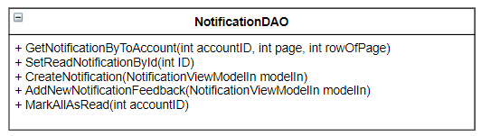

**Class specification**

|  |  |  |
| --- | --- | --- |
| **NO** | **Method** | **Description** |
| 01 | GetNotificationByToAccount(int accountID, int page, int rowOfPage) | Get messages by conversation id |
| 02 | SetReadNotificationById(int ID) | Get messages by sender and receiver |
| 03 | CreateNotification(NotificationViewModelIn modelIn) | Delete an message in an conversation |
| 04 | AddNewNotificationFeedback(NotificationViewModelIn modelIn) | Create a new message then create an conversation if it not belong into an existed conversation |
| 05 | MarkAllAsRead(int accountID) |  |

**4.5.4 Controller**

***4.5.4.1 AuthController***

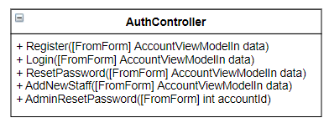

**Class specification**

|  |  |  |
| --- | --- | --- |
| **NO** | **Method** | **Description** |
| 01 | Register([FromForm] AccountViewModelIn data) | Register for an account |
| 02 | Login([FromForm] AccountViewModelIn data) | Login for an user to the system |
| 03 | ResetPassword([FromForm] AccountViewModelIn data) | Reset password for an user |
| 04 | AddNewStaff([FromForm] AccountViewModelIn data) | Add new staff for admin web server |
| 05 | AdminResetPassword([FromForm] int accountId) | Reset password for admin |

## 

## ***4.5.4.2 InfoController***

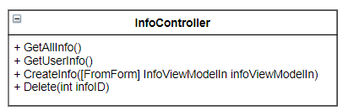

**Class specification**

|  |  |  |
| --- | --- | --- |
| **NO** | **Method** | **Description** |
| 01 | GetAllInfo() | Get all body measurement of all users |
| 02 | GetUserInfo() | Get body measurement of an user |
| 03 | CreateInfo([FromForm] InfoViewModelIn infoViewModelIn) | Create an body measurement for an user |
| 4 | Delete(int infoID) | Delete an body measurement of an user |

## 

## ***4.5.4.3 ProfileController***

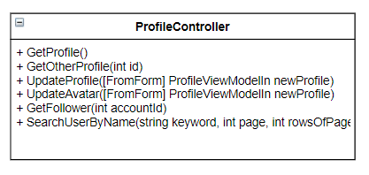

**Class specification**

|  |  |  |
| --- | --- | --- |
| **NO** | **Method** | **Description** |
| 01 | GetProfile() | Get user’s profile |
| 02 | GetOtherProfile(int id) | Get another user’s profile |
| 03 | UpdateProfile([FromForm] ProfileViewModelIn newProfile) | Update user’s profile |
| 04 | UpdateAvatar([FromForm] ProfileViewModelIn newProfile) | Update user’s avatar |
| 05 | GetFollower(int accountId) | Get follower of user |
| 06 | SearchUserByName(string keyword, int page, int rowsOfPage) | Search user by name |

## 

## 

## ***4.5.4.4 PostController***

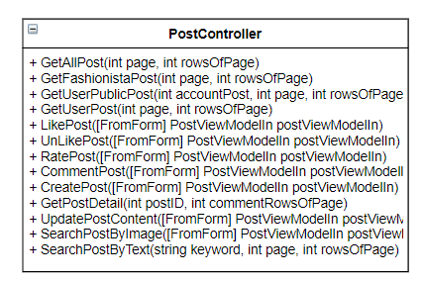

**Class specification**

|  |  |  |
| --- | --- | --- |
| NO | Method | Description |
| 01 | GetAllPost(int page, int rowsOfPage) | Get all users’s posts |
| 02 | GetFashionistaPost(int page, int rowsOfPage) | Get fashionistas’s posts |
| 03 | GetUserPublicPost(int accountPost, int page, int rowsOfPage) | Get public user’s posts |
| 05 | LikePost([FromForm] PostViewModelIn postViewModelIn) | Like a post |
| 06 | UnLikePost([FromForm] PostViewModelIn postViewModelIn) | Unlike a post |
| 07 | RatePost([FromForm] PostViewModelIn postViewModelIn) | Rate a post |
| 08 | CommentPost([FromForm] PostViewModelIn postViewModelIn) | Comment a post |
| 09 | CreatePost([FromForm] PostViewModelIn postViewModelIn) | Create a new post |
| 10 | GetPostDetail(int postID, int commentRowsOfPage) | Get detail of a post |
| 11 | UpdatePostContent([FromForm] PostViewModelIn postViewModelIn) | Update a post’s content |
| 12 | SearchPostByImage([FromForm] PostViewModelIn postViewModelIn) | Search a post by Image |
| 13 | SearchPostByText(string keyword, int page, int rowsOfPage) | Search a post by keyword |

## 

## ***4.5.4.5 NotificationController***

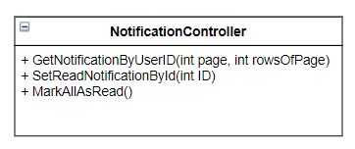

**Class specification**

|  |  |  |
| --- | --- | --- |
| **NO** | **Method** | **Description** |
| 01 | GetNotificationByUserID(int page, int rowsOfPage) | Get notification of user |
| 02 | SetReadNotificationById(int ID) | Set a notification is read |
| 03 | MarkAllAsRead() | Set all notifications are read |

## 

## ***4.5.4.6 MessageController***

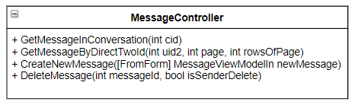

**Class specification**

|  |  |  |
| --- | --- | --- |
| **NO** | **Method** | **Description** |
| 01 | GetMessageInConversation(int cid) | Get messages in a conversation |
| 02 | GetMessageByDirectTwoId(int uid2, int page, int rowsOfPage) | Get messages by user |
| 03 | CreateNewMessage([FromForm] MessageViewModelIn newMessage) | Send a message to another user |
| 04 | DeleteMessage(int messageId, bool isSenderDelete) | Delete a message |

## 

## ***4.5.4.7 ConversationController***

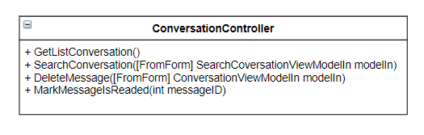

**Class specification**

|  |  |  |
| --- | --- | --- |
| **NO** | **Method** | **Description** |
| 01 | GetListConversation() | Get list user’s conversation |
| 02 | SearchConversation([FromForm] SearchCoversationViewModelIn modelIn) | Search conversation by username |
|  | DeleteMessage([FromForm] ConversationViewModelIn modelIn) | Delete a conversation |
|  | MarkMessageIsReaded(int messageID) | Mark conversation is read |

## 

## 

## **4.6. Sequence Diagram**

***4.6.1. UC-01 View recruitment process***

## **4.7. User Interface Design**

## ***4.7.1. Screen Images***

1. Candidate:
   * Home page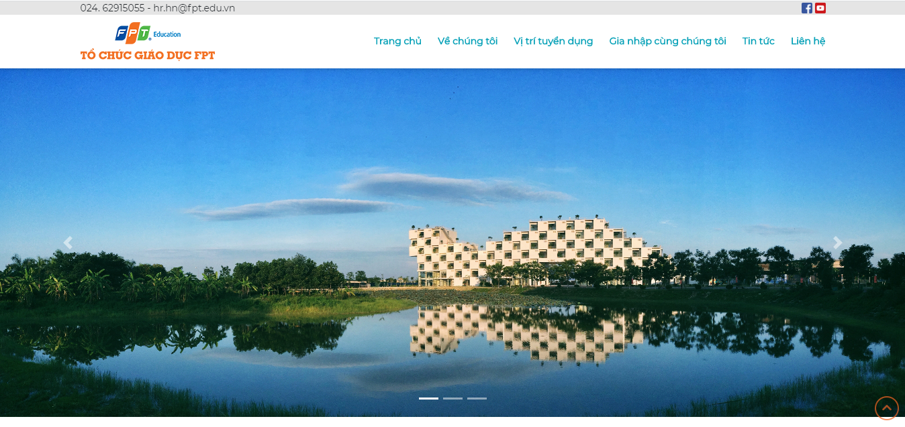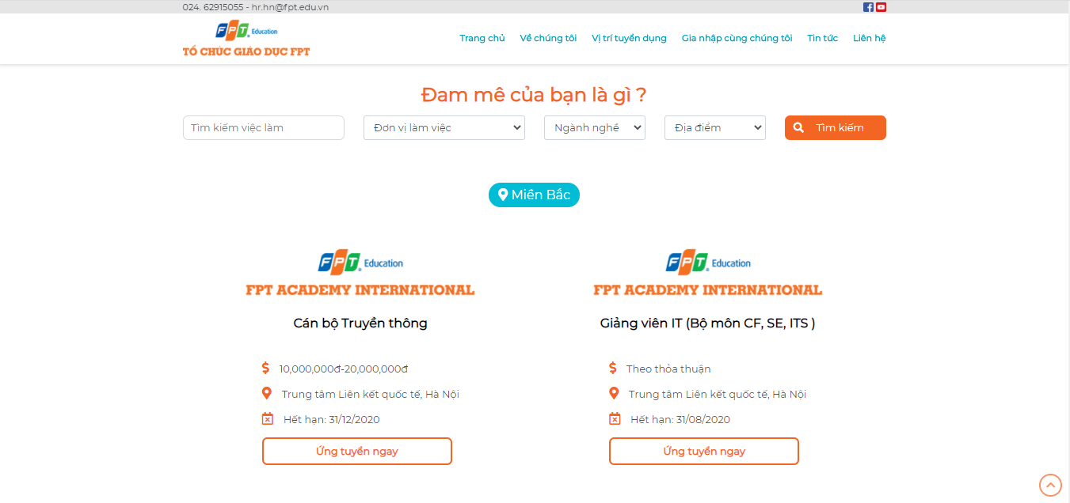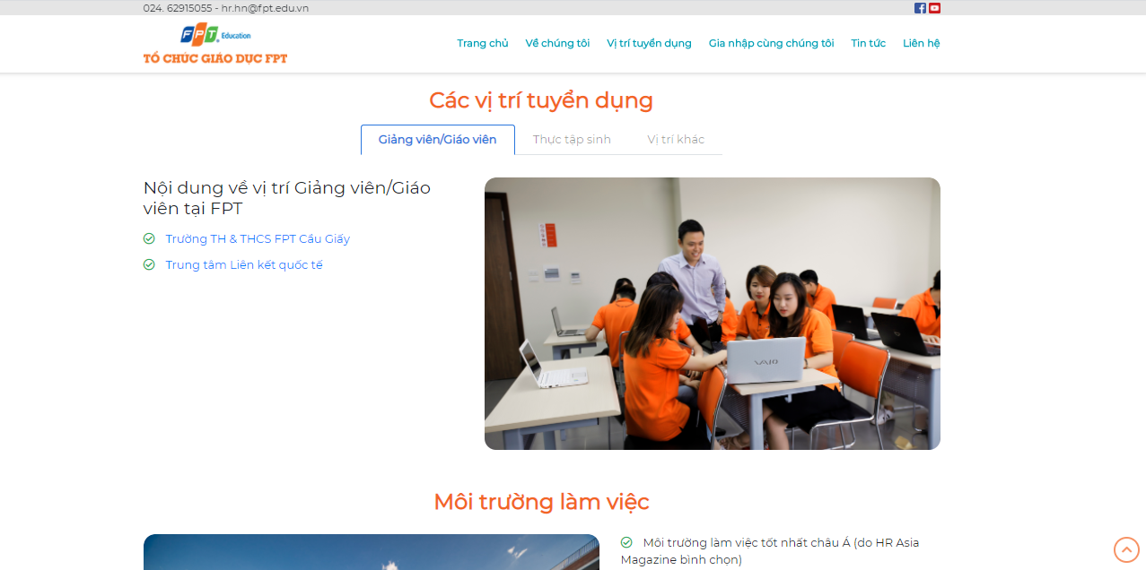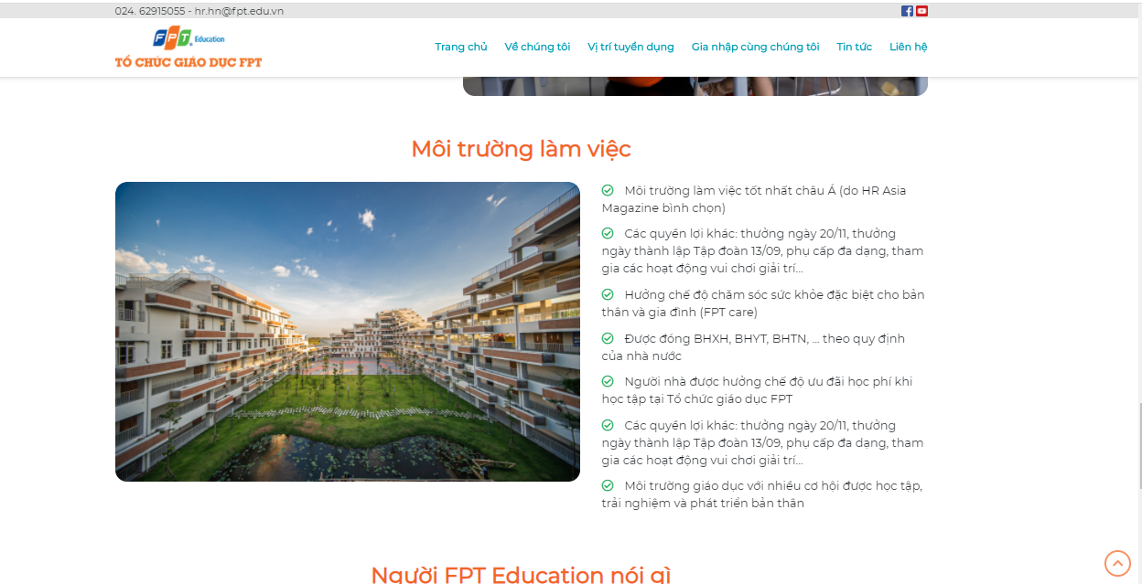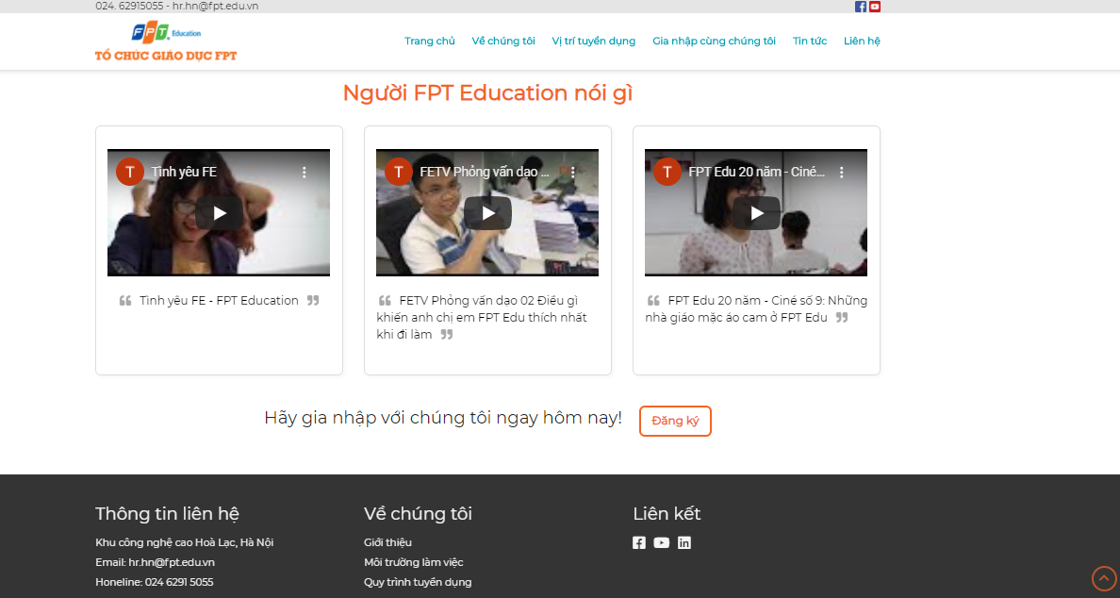
   * Job list

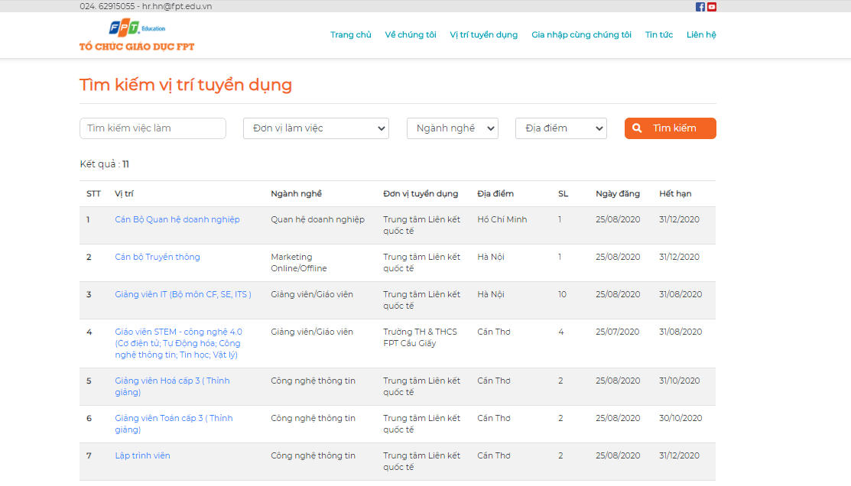

* + Job detail

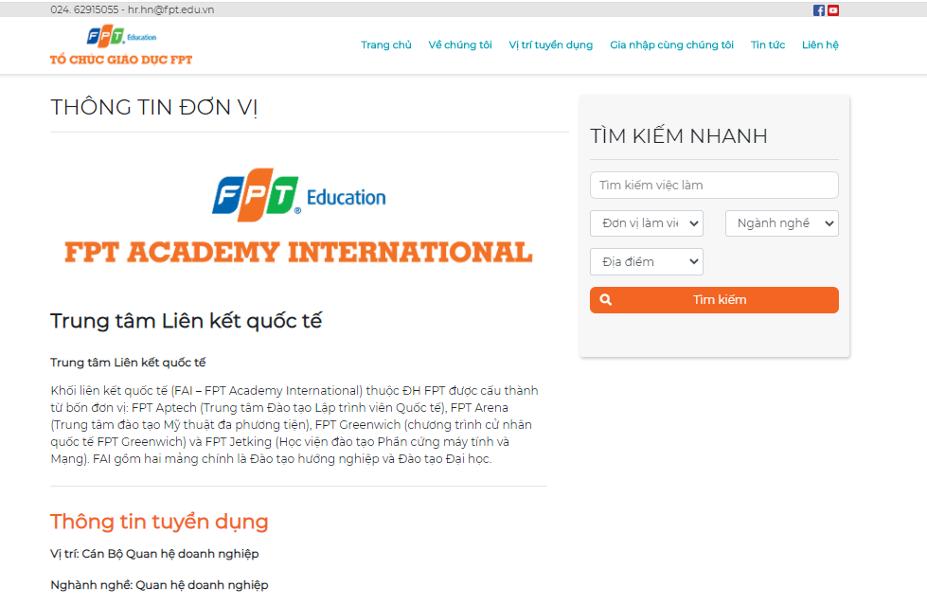

* + Recruitment process

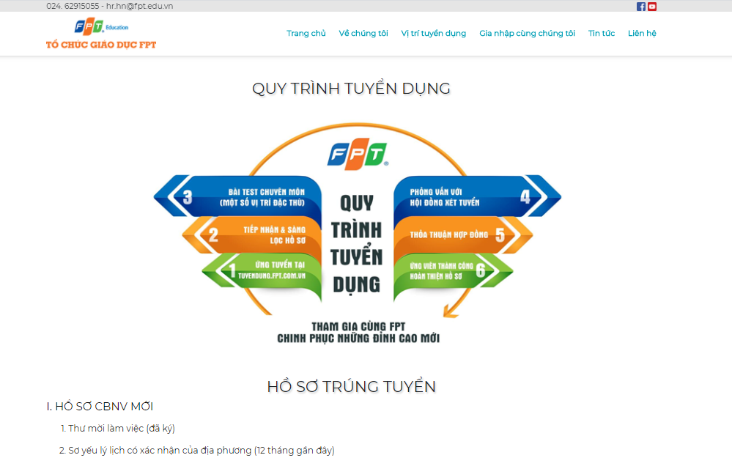

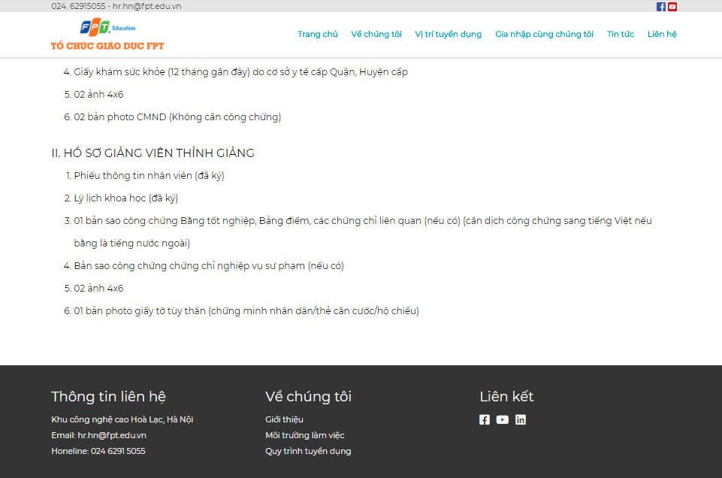

1. Admin:
   * Account management screen

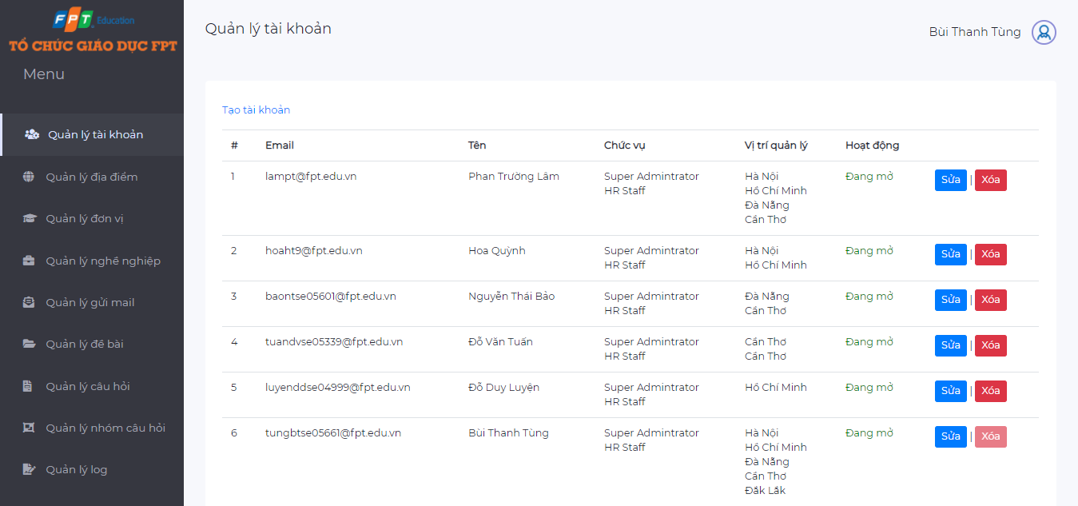

* + Career management screen

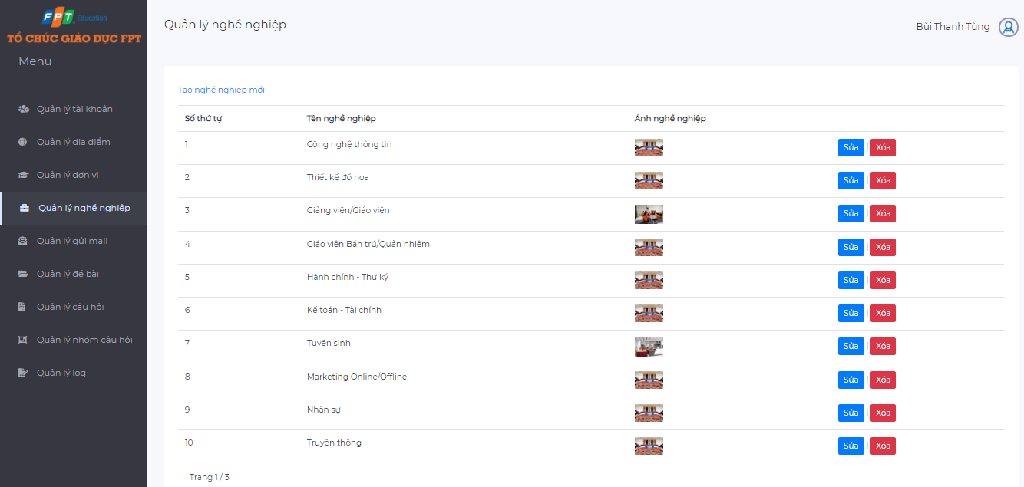

* + Config email management screen

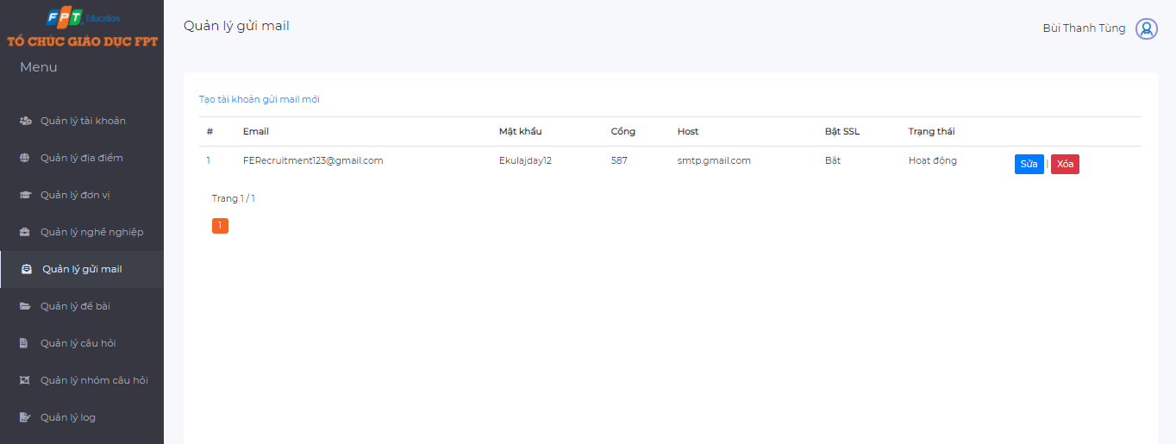

* + Location management screen

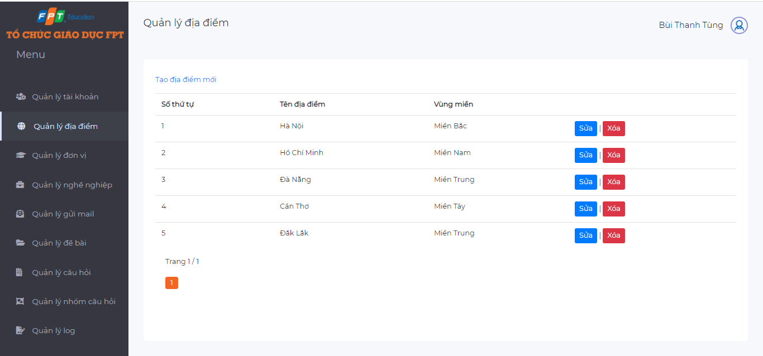

* + Unit management screen

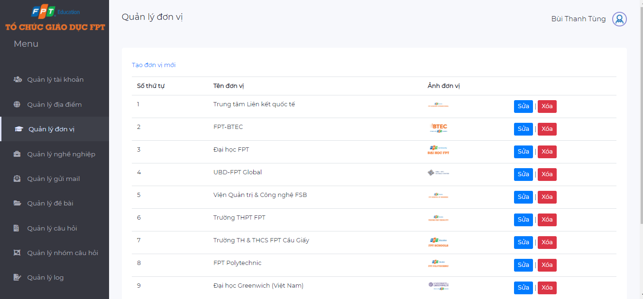

* + Question management screen

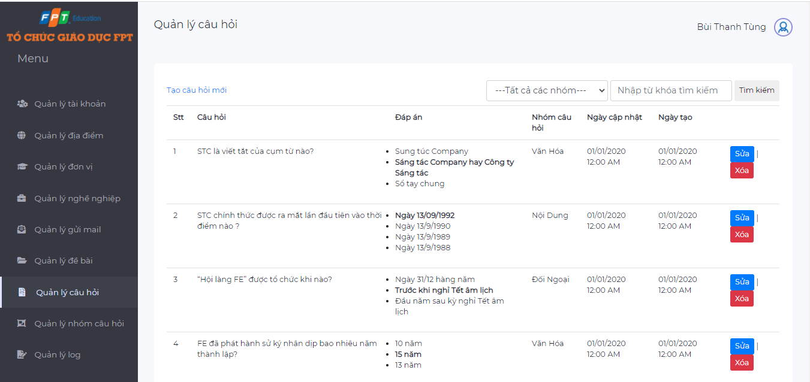

* + Question group management screen

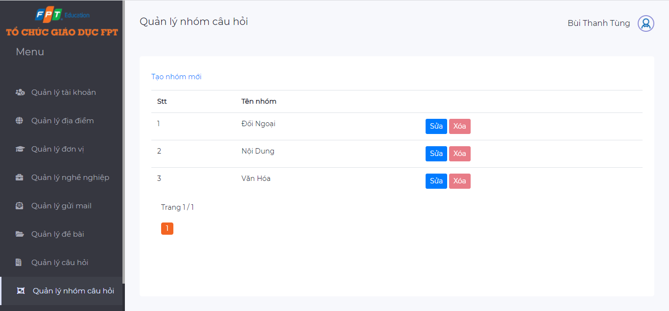

* + Quiz management screen

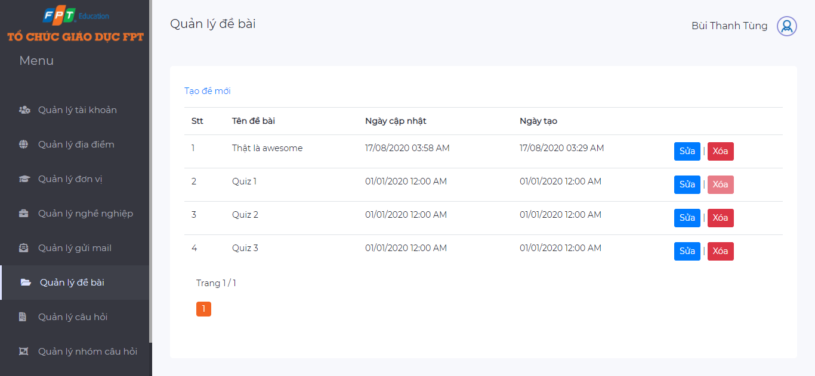

* + Log management screen

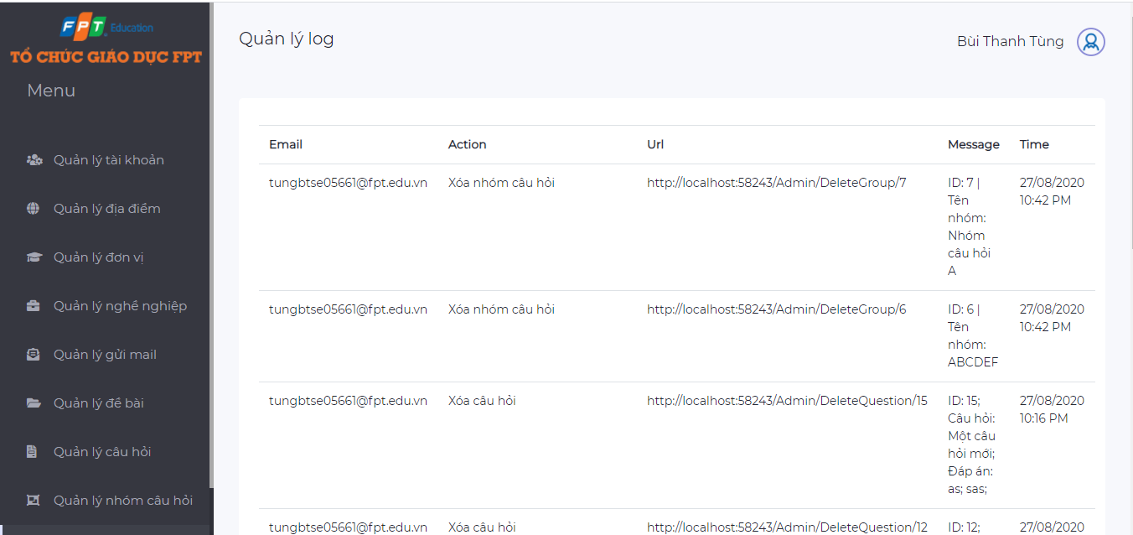

1. HR Staff:
   * Job management screen

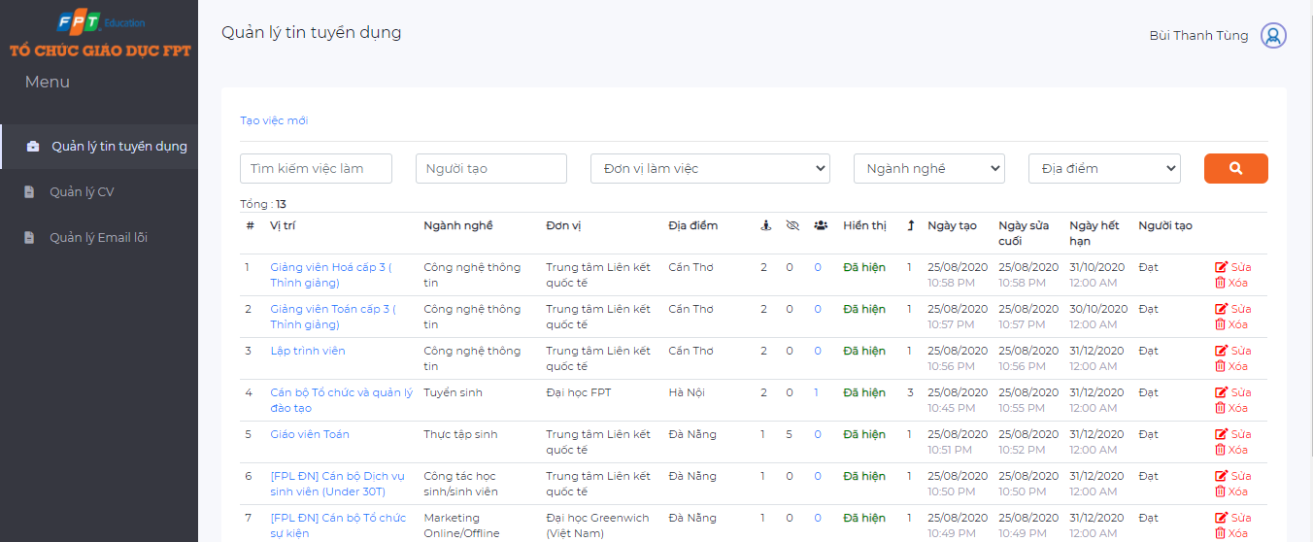

* + CV management screen

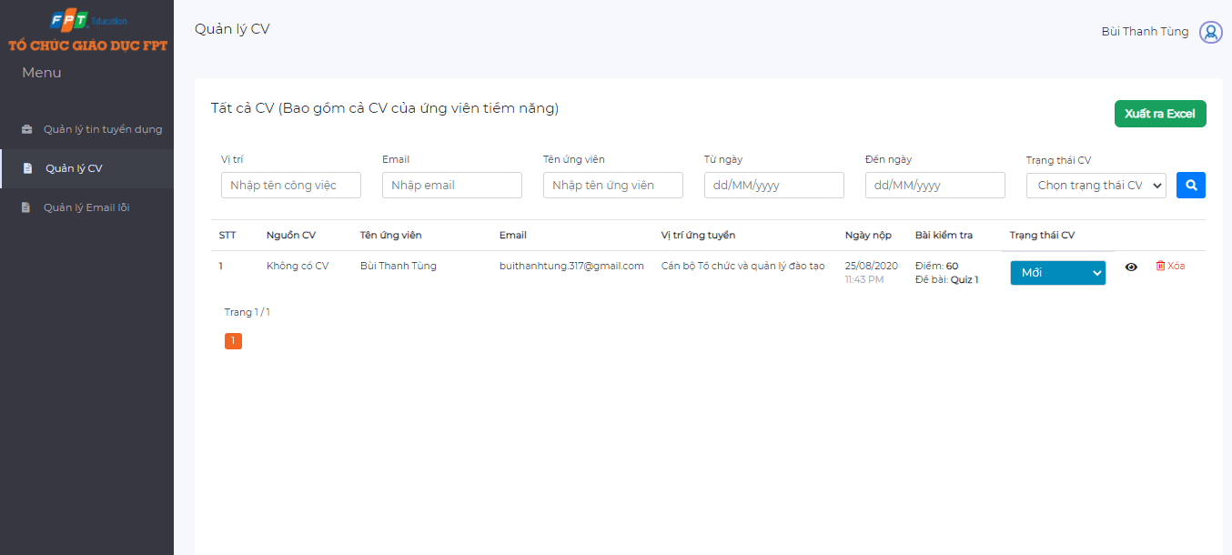

* + Error email management screen

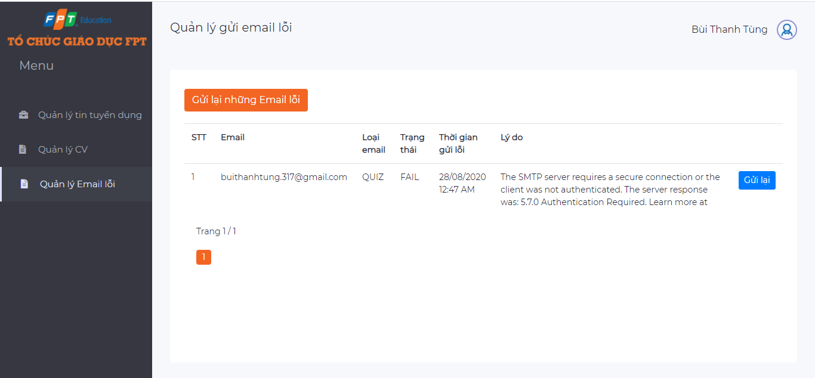

## **4.8. Database Design**

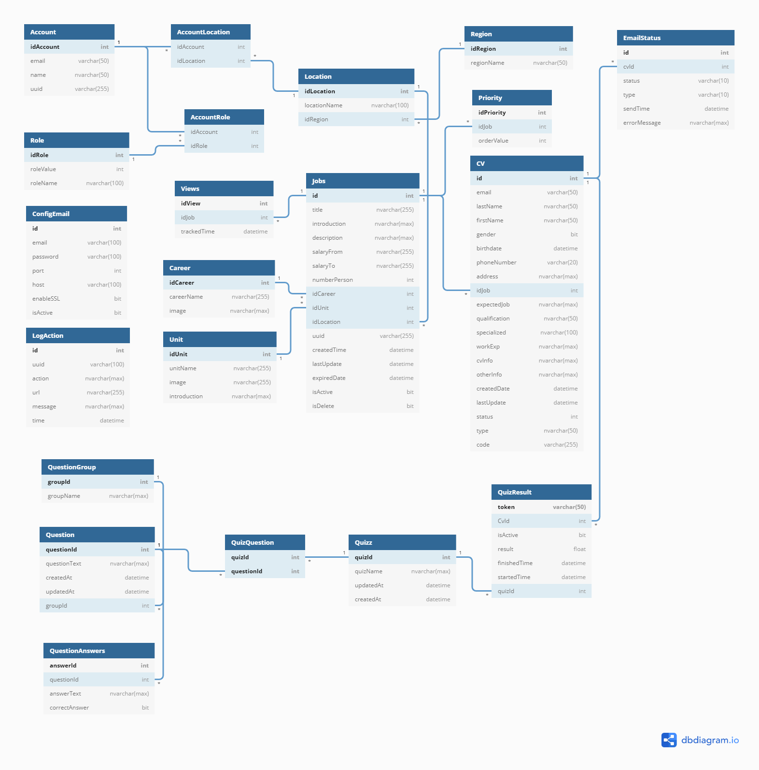

#### ***4.8.1. Account***

* Entity table to store account related data
* Table structure

|  |  |  |  |  |  |  |  |
| --- | --- | --- | --- | --- | --- | --- | --- |
| Field name | Type | Size | Unique | Not Null | PK | FK | Notes |
| idAccount | int |  | ✓ | ✓ | ✓ |  |  |
| email | varchar | 50 |  | ✓ |  |  |  |
| name | varchar | 50 |  | ✓ |  |  |  |
| uuid | varchar | 255 |  | ✓ |  |  |  |
| isActive | bit |  |  |  |  |  |  |

#### ***4.8.2. AccountRole***

* Entity table to store information that tie between 2 tables Account and Role
* Table structure

|  |  |  |  |  |  |  |  |
| --- | --- | --- | --- | --- | --- | --- | --- |
| Field name | Type | Size | Unique | Not Null | PK | FK | Notes |
| idAccount | int |  |  | ✓ |  | ✓ | Fk: idAccount of Account |
| idRole | int |  |  | ✓ |  | ✓ | Fk: idRole of Role |

#### ***4.8.3. AccountLocation***

* Entity table to store information that tie between 2 tables Account and Location
* Table structure

|  |  |  |  |  |  |  |  |
| --- | --- | --- | --- | --- | --- | --- | --- |
| Field name | Type | Size | Unique | Not Null | PK | FK | Notes |
| idAccount | int |  |  | ✓ |  | ✓ | Fk: idAccount of Account |
| idLocation | int |  |  | ✓ |  | ✓ | Fk: idLocation of Location |

#### ***4.8.4. Career***

* Entity table to store career related data
* Table structure

|  |  |  |  |  |  |  |  |
| --- | --- | --- | --- | --- | --- | --- | --- |
| Field name | Type | Size | Unique | Not Null | PK | FK | Notes |
| idCareer | int |  | ✓ | ✓ | ✓ |  |  |
| careerName | nvarchar | 255 |  | ✓ |  |  |  |
| image | nvarchar | Max |  |  |  |  |  |

#### ***4.8.5. ConfigEmail***

* Entity table to store config email related data
* Table structure

|  |  |  |  |  |  |  |  |
| --- | --- | --- | --- | --- | --- | --- | --- |
| Field name | Type | Size | Unique | Not Null | PK | FK | Notes |
| id | int |  | ✓ | ✓ | ✓ |  |  |
| email | varchar | 100 |  |  |  |  |  |
| password | varchar | 100 |  |  |  |  |  |
| port | int |  |  |  |  |  |  |
| host | varchar | 100 |  |  |  |  |  |
| enableSSL | bit |  |  |  |  |  |  |
| isActive | bit |  |  |  |  |  |  |

#### ***4.8.6. CV***

* Entity table to store CV related data
* Table structure

|  |  |  |  |  |  |  |  |
| --- | --- | --- | --- | --- | --- | --- | --- |
| Field name | Type | Size | Unique | Not Null | PK | FK | Notes |
| id | int |  | ✓ | ✓ | ✓ |  |  |
| email | varchar | 50 |  | ✓ |  |  |  |
| lastName | varchar | 50 |  | ✓ |  |  |  |
| fistName | varchar | 50 |  | ✓ |  |  |  |
| gender | bit |  |  | ✓ |  |  |  |
| birthdate | datetime |  |  | ✓ |  |  |  |
| phoneNumber | varchar | 20 |  | ✓ |  |  |  |
| address | nvarchar | Max |  | ✓ |  |  |  |
| idJob | int |  |  |  |  | ✓ |  |
| expectedJob | nvarchar | Max |  |  |  |  |  |
| qualification | nvarchar | 50 |  |  |  |  |  |
| specialized | nvarchar | 100 |  |  |  |  |  |
| workExp | nvarchar | Max |  |  |  |  |  |
| cvInfo | nvarchar | Max |  |  |  |  |  |
| createDate | datetime |  |  | ✓ |  |  |  |
| lastUpdate | datetime |  |  | ✓ |  |  |  |
| status | int |  |  | ✓ |  |  |  |
| type | nvarchar | 50 |  |  |  |  |  |
| code | varchar | 255 |  |  |  |  |  |

#### 

#### ***4.8.7. EmailStatus***

* Entity table to store email status related data
* Table structure

|  |  |  |  |  |  |  |  |
| --- | --- | --- | --- | --- | --- | --- | --- |
| Field name | Type | Size | Unique | Not Null | PK | FK | Notes |
| id | int |  | ✓ | ✓ | ✓ |  |  |
| cvId | int |  |  |  |  | ✓ | Fk: id of CV |
| status | varchar | 10 |  |  |  |  |  |
| type | varchar | 10 |  |  |  |  |  |
| sendTime | datetime |  |  |  |  |  |  |
| errorMessage | nvarchar | Max |  |  |  |  |  |

#### ***4.8.8. Job***

* Entity table to store job related data
* Table structure

|  |  |  |  |  |  |  |  |
| --- | --- | --- | --- | --- | --- | --- | --- |
| Field name | Type | Size | Unique | Not Null | PK | FK | Notes |
| id | int |  | ✓ | ✓ | ✓ |  |  |
| title | nvarchar | 255 |  | ✓ |  |  |  |
| introduction | nvarchar | Max |  | ✓ |  |  |  |
| description | nvarchar | Max |  | ✓ |  |  |  |
| salary | nvarchar | 255 |  | ✓ |  |  |  |
| numberPerson | int |  |  | ✓ |  |  |  |
| idCareer | int |  |  |  | ✓ |  | Fk: idCareer of Career |
| idUnit | int |  |  |  | ✓ |  | Fk: idUnit of Unit |
| idLocation | int |  |  |  | ✓ |  | Fk: idLocation of Location |
| uuid | varchar | 255 |  |  |  |  |  |
| createdTime | datetime |  |  | ✓ |  |  |  |
| lastUpdate | datetime |  |  | ✓ |  |  |  |
| expiredDate | datetime |  |  | ✓ |  |  |  |
| isActive | bit |  |  | ✓ |  |  |  |
| isDelete | bit |  |  | ✓ |  |  |  |

#### ***4.8.9. Location***

* Entity table to store location related data
* Table structure

|  |  |  |  |  |  |  |  |
| --- | --- | --- | --- | --- | --- | --- | --- |
| Field name | Type | Size | Unique | Not Null | PK | FK | Notes |
| idLocation | int |  | ✓ | ✓ | ✓ |  |  |
| locationName | nvarchar | 100 |  |  |  | ✓ |  |
| idRegion | int |  |  |  |  | ✓ | Fk: idRegion of Region |

#### ***4.8.10. LogAction***

* Entity table to store log action related data
* Table structure

|  |  |  |  |  |  |  |  |
| --- | --- | --- | --- | --- | --- | --- | --- |
| Field name | Type | Size | Unique | Not Null | PK | FK | Notes |
| id | int |  | ✓ | ✓ | ✓ |  |  |
| uuid | varchar | 100 |  |  |  |  |  |
| action | nvarchar | Max |  |  |  |  |  |
| url | nvarchar | 255 |  |  |  |  |  |
| message | nvarchar | Max |  |  |  |  |  |
| time | datetime |  |  |  |  |  |  |

#### ***4.8.11. Priority***

* Entity table to store priority related data
* Table structure

|  |  |  |  |  |  |  |  |
| --- | --- | --- | --- | --- | --- | --- | --- |
| Field name | Type | Size | Unique | Not Null | PK | FK | Notes |
| idPriority | int |  | ✓ | ✓ | ✓ |  |  |
| idJob | int |  |  | ✓ |  |  | Fk: id of Job |
| orderValue | int |  |  | ✓ |  |  |  |

#### ***4.8.12. Question***

* Entity table to store question related data
* Table structure

|  |  |  |  |  |  |  |  |
| --- | --- | --- | --- | --- | --- | --- | --- |
| Field name | Type | Size | Unique | Not Null | PK | FK | Notes |
| questionId | int |  | ✓ | ✓ | ✓ |  |  |
| questionText | nvarchar | Max |  | ✓ |  |  |  |
| createdAt | datetime |  |  |  |  |  |  |
| updateAt | datetime |  |  |  |  |  |  |
| groupId | int |  |  |  |  | ✓ | Fk : groupId of QuestionGroup |

#### ***4.8.13. QuestionAnswer***

* Entity table to store question answer related data
* Table structure

|  |  |  |  |  |  |  |  |
| --- | --- | --- | --- | --- | --- | --- | --- |
| Field name | Type | Size | Unique | Not Null | PK | FK | Notes |
| answerId | int |  | ✓ | ✓ | ✓ |  |  |
| questionId | int |  |  |  |  | ✓ | Fk: questionId of Question |
| answerText | nvarchar | Max |  | ✓ |  |  |  |
| correctAnswer | bit |  |  | ✓ |  |  |  |

#### ***4.8.14. QuestionGroup***

* Entity table to store question group related data
* Table structure

|  |  |  |  |  |  |  |  |
| --- | --- | --- | --- | --- | --- | --- | --- |
| Field name | Type | Size | Unique | Not Null | PK | FK | Notes |
| groupId | int |  | ✓ | ✓ | ✓ |  |  |
| groupName | nvarchar | Max |  |  |  | ✓ | Fk: questionId of Question |

#### ***4.8.15. Quiz***

* Entity table to store quiz related data
* Table structure

|  |  |  |  |  |  |  |  |
| --- | --- | --- | --- | --- | --- | --- | --- |
| Field name | Type | Size | Unique | Not Null | PK | FK | Notes |
| quizId | int |  | ✓ | ✓ | ✓ |  |  |
| quizName | nvarchar | Max |  |  |  |  |  |
| updateAt | datetime |  |  |  |  |  |  |
| createAt | datetime |  |  |  |  |  |  |

#### ***4.8.16. QuizQuestion***

* Entity table to store quiz question related data
* Table structure

|  |  |  |  |  |  |  |  |
| --- | --- | --- | --- | --- | --- | --- | --- |
| Field name | Type | Size | Unique | Not Null | PK | FK | Notes |
| quizId | int |  |  | ✓ |  | ✓ | Fk : quizId of Quiz |
| questionId | int |  |  | ✓ |  | ✓ | Fk : questionId of Question |

#### ***4.8.17. QuizResult***

* Entity table to store quiz result related data
* Table structure

|  |  |  |  |  |  |  |  |
| --- | --- | --- | --- | --- | --- | --- | --- |
| Field name | Type | Size | Unique | Not Null | PK | FK | Notes |
| token | varchar | 50 | ✓ | ✓ | ✓ |  |  |
| CvId | int |  |  |  |  | ✓ | Fk: id of CV |
| isActive | bit |  |  | ✓ |  |  |  |
| result | float |  |  |  |  |  |  |
| finishedTime | datetime |  |  |  |  |  |  |
| startedTime | datetime |  |  |  |  |  |  |
| quizId | int |  |  |  |  | ✓ | Fk: quizId of Quiz |

#### ***4.8.18. Region***

* Entity table to store region related data
* Table structure

|  |  |  |  |  |  |  |  |
| --- | --- | --- | --- | --- | --- | --- | --- |
| Field name | Type | Size | Unique | Not Null | PK | FK | Notes |
| idRegion | int |  | ✓ | ✓ | ✓ |  |  |
| regionName | nvarchar | 50 |  | ✓ |  |  |  |

#### ***4.8.19. Role***

* Entity table to store role related data
* Table structure

|  |  |  |  |  |  |  |  |
| --- | --- | --- | --- | --- | --- | --- | --- |
| Field name | Type | Size | Unique | Not Null | PK | FK | Notes |
| idRole | int |  | ✓ | ✓ | ✓ |  |  |
| roleValue | int |  |  | ✓ |  |  |  |
| roleName | nvarchar | 100 |  | ✓ |  |  |  |

#### ***4.8.20. Unit***

* Entity table to store unit related data
* Table structure

|  |  |  |  |  |  |  |  |
| --- | --- | --- | --- | --- | --- | --- | --- |
| Field name | Type | Size | Unique | Not Null | PK | FK | Notes |
| idUnit | int |  | ✓ | ✓ | ✓ |  |  |
| unitName | nvarchar | 255 |  |  |  |  |  |
| image | nvarchar | 255 |  |  |  |  |  |
| introduction | nvarchar | Max |  |  |  |  |  |

#### ***4.8.21. View***

* Entity table to store view related data
* Table structure

|  |  |  |  |  |  |  |  |
| --- | --- | --- | --- | --- | --- | --- | --- |
| Field name | Type | Size | Unique | Not Null | PK | FK | Notes |
| idView | int |  | ✓ | ✓ | ✓ |  |  |
| idJob | int |  |  | ✓ |  | ✓ | Fk: id of Job |
| trackedTime | datetime |  |  | ✓ |  |  |  |

#### 

1. HMAC-based One-time Password: <https://en.wikipedia.org/wiki/HMAC-based_One-time_Password_algorithm>
2.
3.
4.